[**NetCDF Viewer**](https://agrimetsoft.com/NetCDF-Viewer.aspx)

[NetCDF Viewer](https://agrimetsoft.com/NetCDF-Viewer.aspx) is a free windows tool for view the content of [NetCDF files](https://agrimetsoft.com/NetCDF-Extractor.aspx). [NetCDF Viewer](https://agrimetsoft.com/NetCDF-Viewer.aspx) has five section for show the data.

1. Variables section
2. Global Attributes
3. Attributes
4. Dimensions

If you open the file like as bellow figure then [NetCDF Viewer](https://agrimetsoft.com/NetCDF-Viewer.aspx) will fill the variables section by Radio-Buttons and global attributes by global attributes of files.

**Step1**: Click on open icon on top to open file dialog.

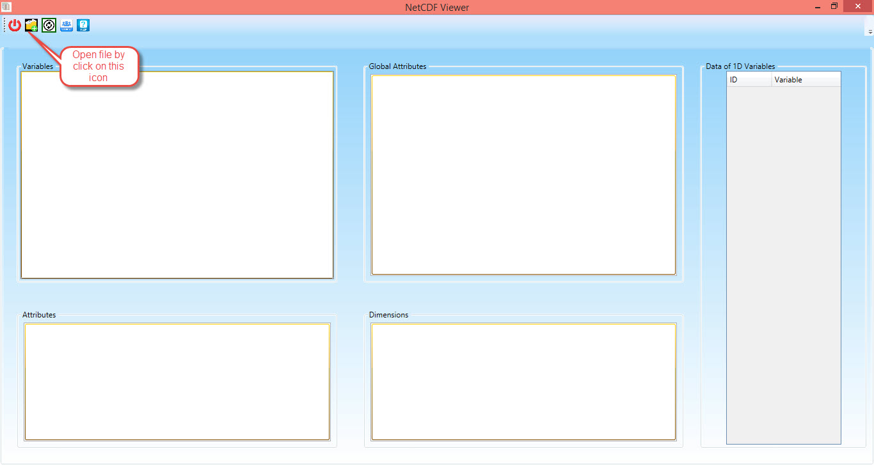

Figure - Click on Open Icon

**Step2**: Select your favorite file and then click on open button.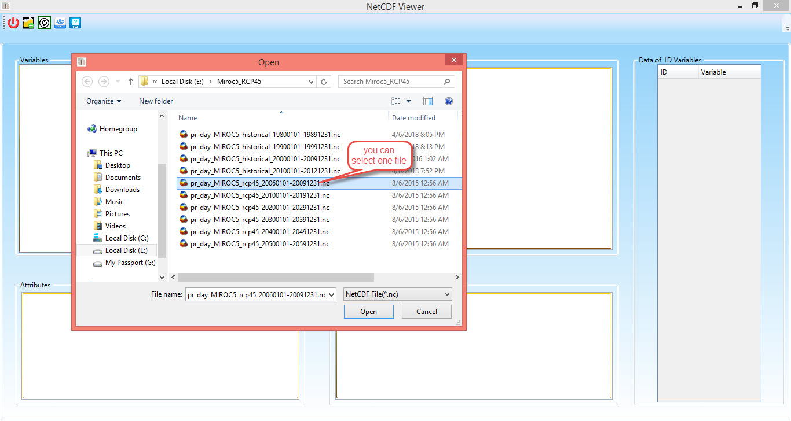

Figure - Select you file

**Step3:** in this step, you can view the global attributes and you can select the favorite variables then [NetCDF Viewer](https://agrimetsoft.com/NetCDF-Viewer.aspx) will show the dimensions and attributes of the variables.

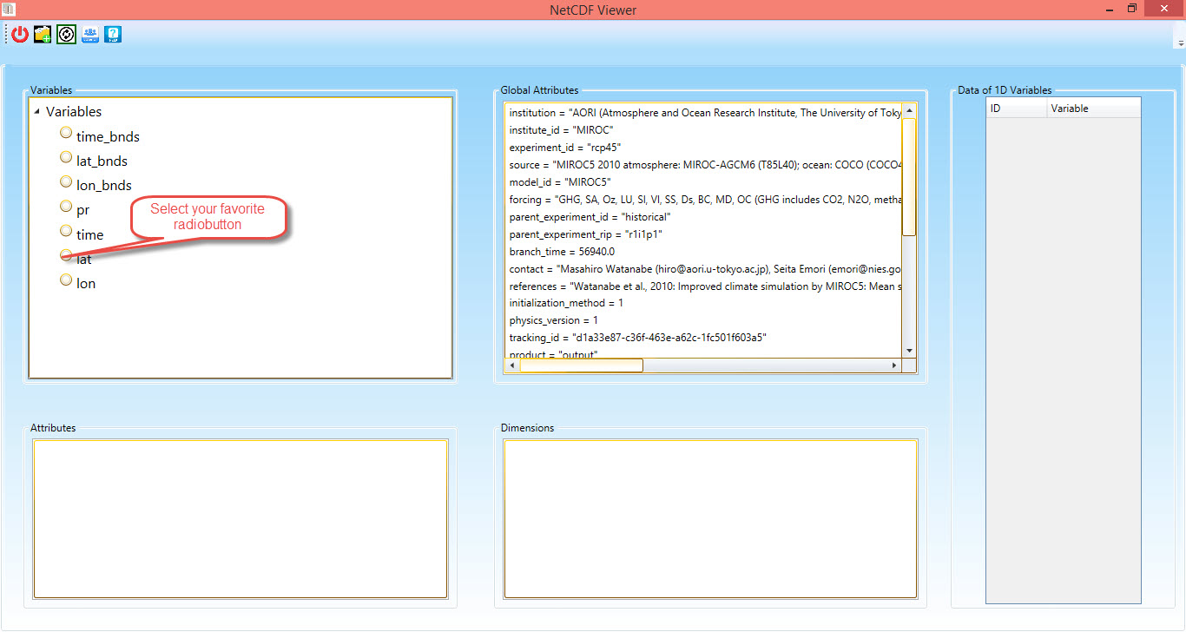

Figure - Select Variable

**Step4:** You can view the data of one dimension variables in the table. If you want you can copy all data and paste it in your favorite files such as excel files.

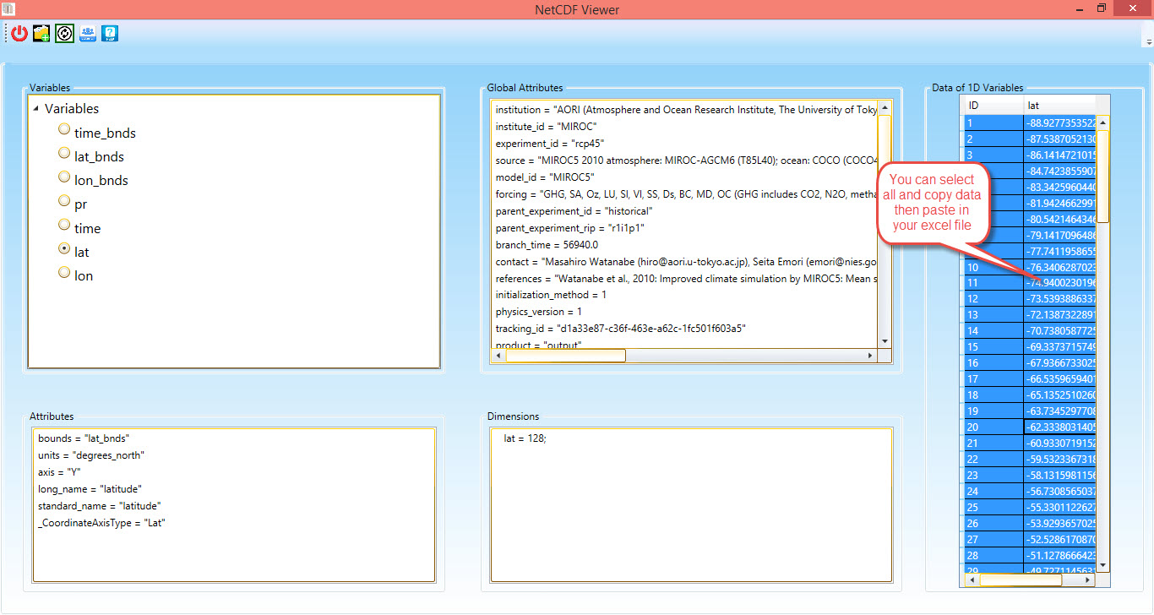

Figure - View one dim data